# User guidence simulation

250 points

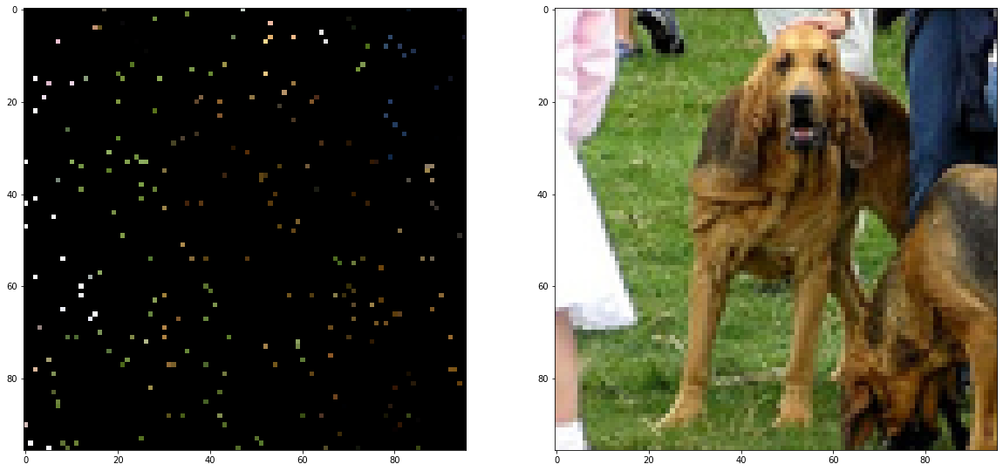

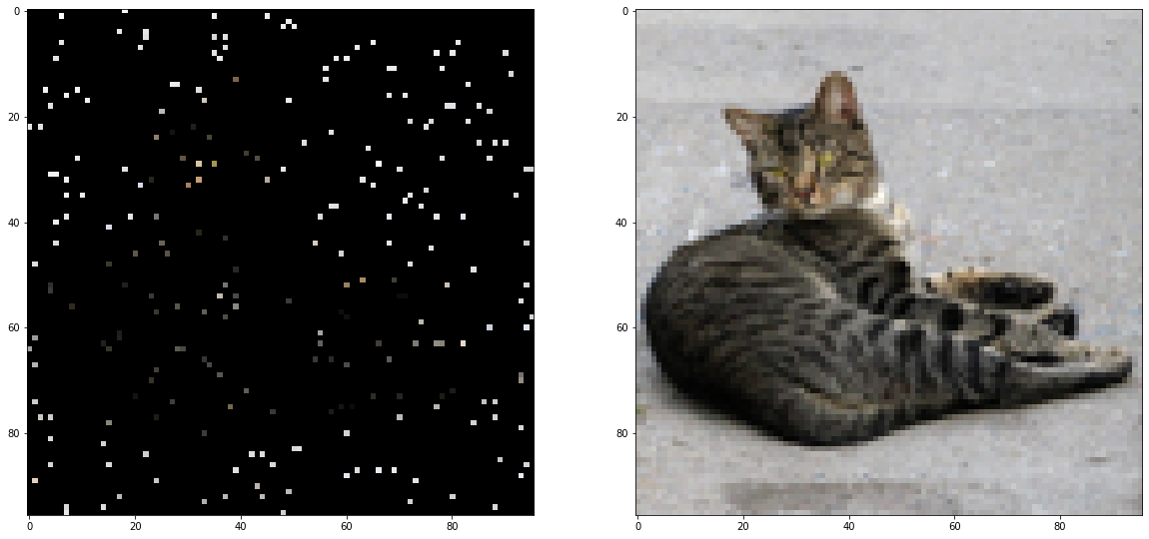

500 points

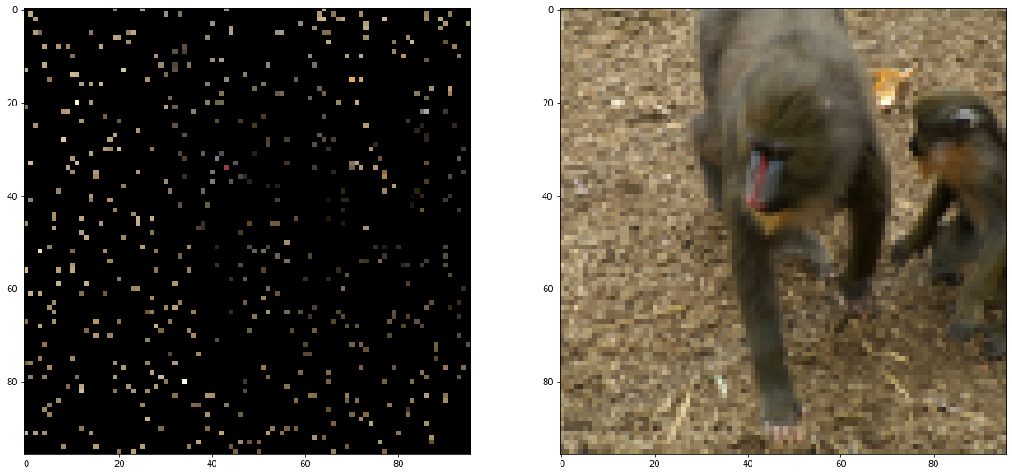

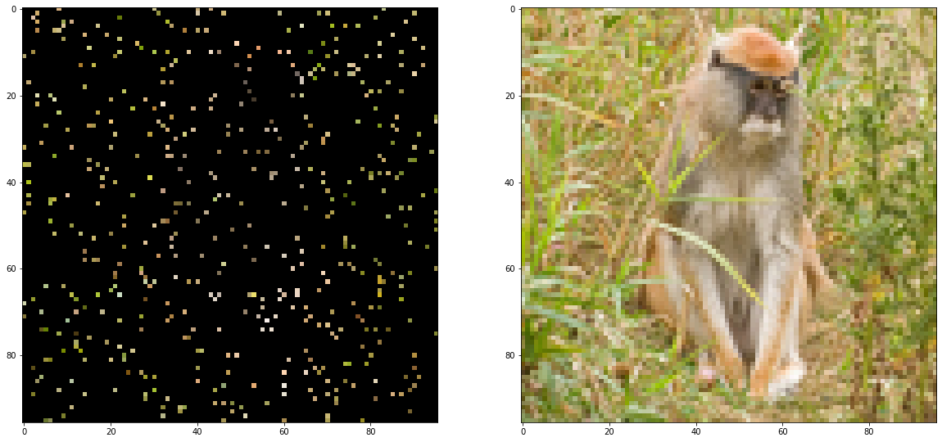

# Improvements to do

1. Use a random number of points at each image training. For now it is static for all the training images
2. Add more layers:
   1. Add more residual layers (the same number as the mentioned in the paper of cGAN)
   2. Add 2 more downsampling convolution and 2 more upsampling convolution

With these changes, we will obtain almost the same architecture proposed in the cGAN paper

# Results

## Results 1

Generator: 2 downsamplig convolutions + 4 residual blocks + 2 upsampling convolutions

[Discriminator](https://jamboard.google.com/d/19FXoqFzUnmpMWVM0eTERcEKjHk7U_L-CKrbChdrGAGo/viewer?f=0): Two scale discriminators with [PatchGan](https://sahiltinky94.medium.com/understanding-patchgan-9f3c8380c207)

# Define Geneartor and Discriminator networks

gan_gen = Generator(img_channels = 4, base_channels = 64, out_channels = 3)

gan_disc = Discriminator(input_channels=6, base_channels=64)

#Initialize indepdent optimizer for both networks

learning_rate = .0005

optimizer_gen = torch.optim.Adam(gan_gen.parameters(),lr = learning_rate, weight_decay=1e-5)

optimizer_disc = torch.optim.Adam(gan_disc.parameters(),lr = learning_rate, weight_decay=1e-5)

# Train the GAN

device = torch.device('cuda:0' if torch.cuda.is_available() else 'cpu')

loss_list = train_GAN(gan_gen,gan_disc, train_dataloader_stl_10, optimizer_gen, optimizer_disc,

num_epochs=20, model_name='cgan_stl_10.ckpt', device=device)

Also, we have fixed 200 points at every mask. We need to test varying this

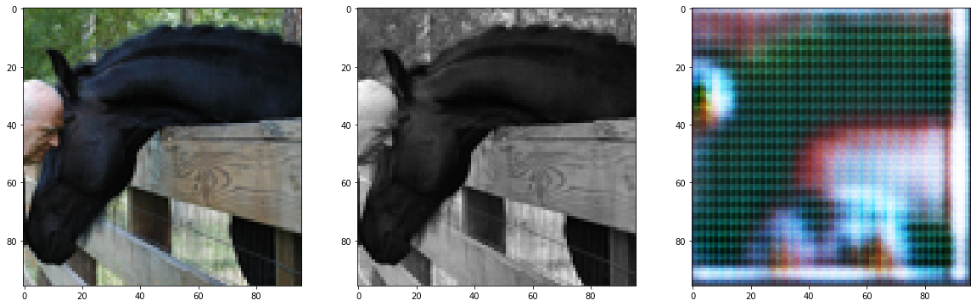

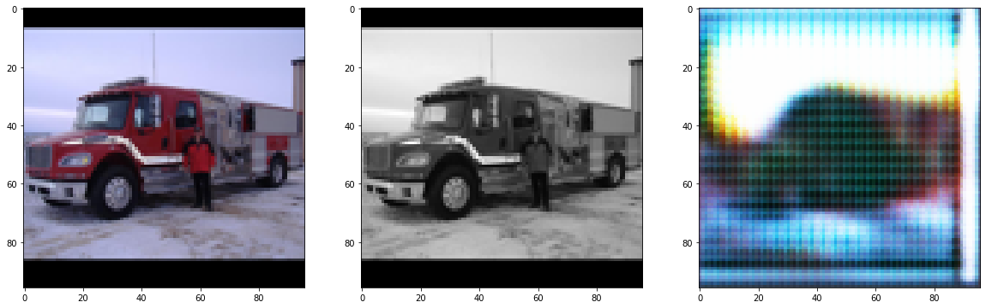

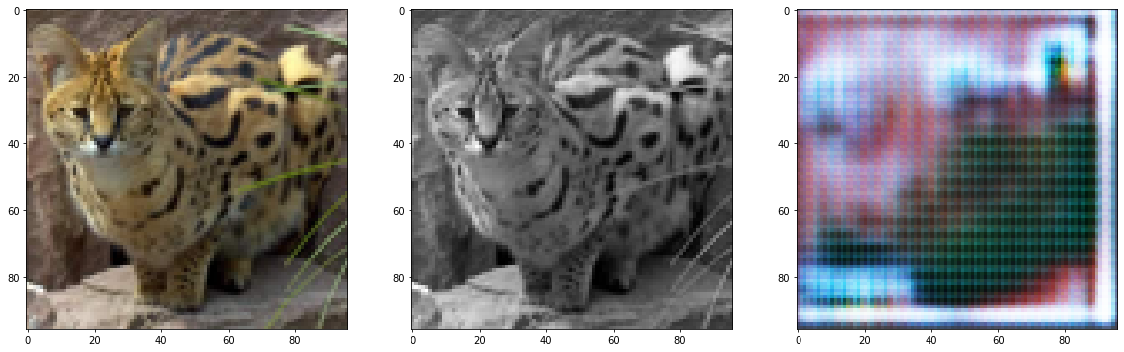

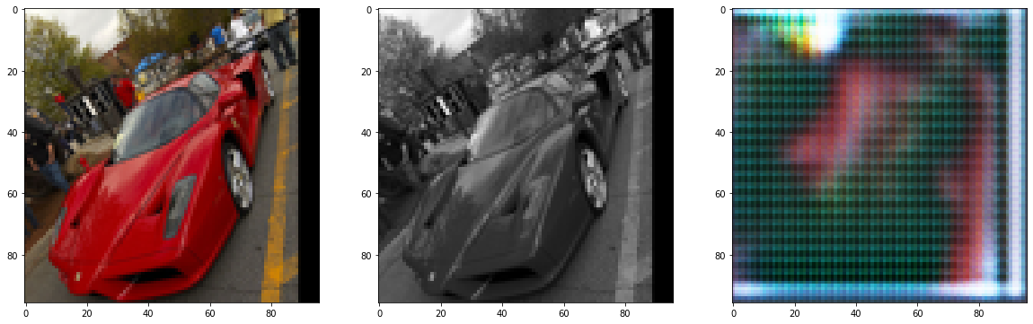

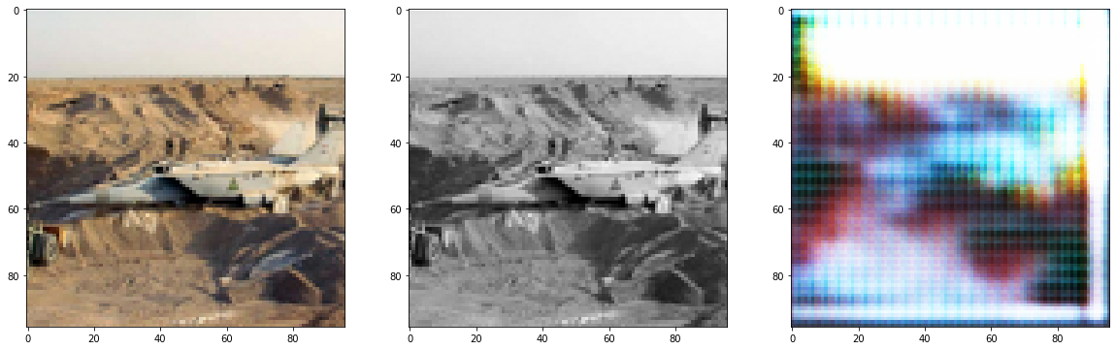

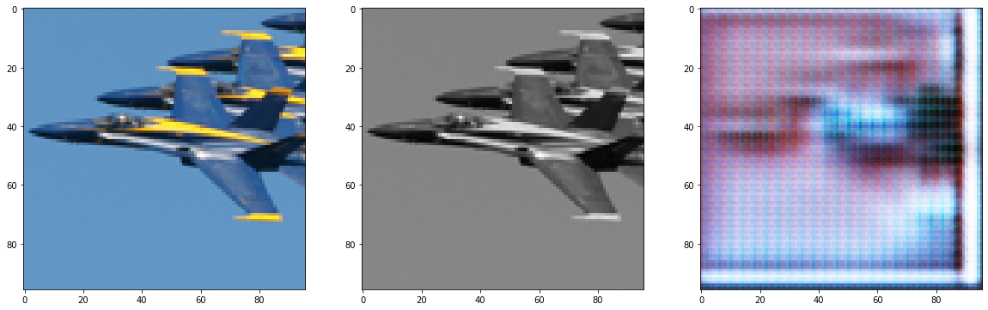

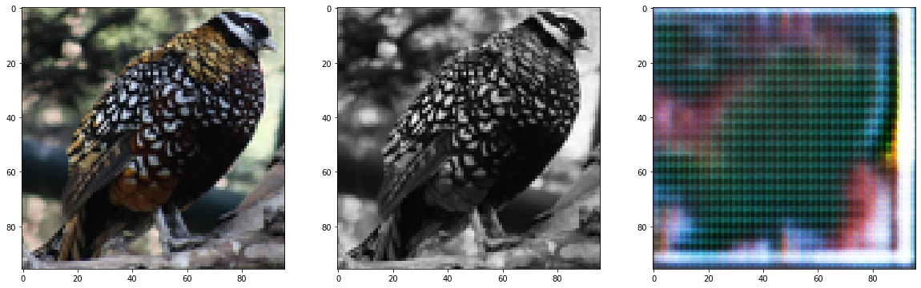

## Results 2

# Define Geneartor and Discriminator networks

gan_gen = Generator(img_channels = 4, base_channels = 64, out_channels = 3)

gan_disc = Discriminator(input_channels=6, base_channels=64)

#Initialize indepdent optimizer for both networks

learning_rate = .0005

optimizer_gen = torch.optim.Adam(gan_gen.parameters(),lr = learning_rate, weight_decay=1e-5)

optimizer_disc = torch.optim.Adam(gan_disc.parameters(),lr = learning_rate, weight_decay=1e-5)

num_epochs = 50

# Train the GAN

device = torch.device('cuda:0' if torch.cuda.is_available() else 'cpu')

loss_list = train_GAN(gan_gen,gan_disc, train_dataloader_stl_10, optimizer_gen, optimizer_disc,

num_epochs=num_epochs, model_name='cgan_stl_10.ckpt', device=device)

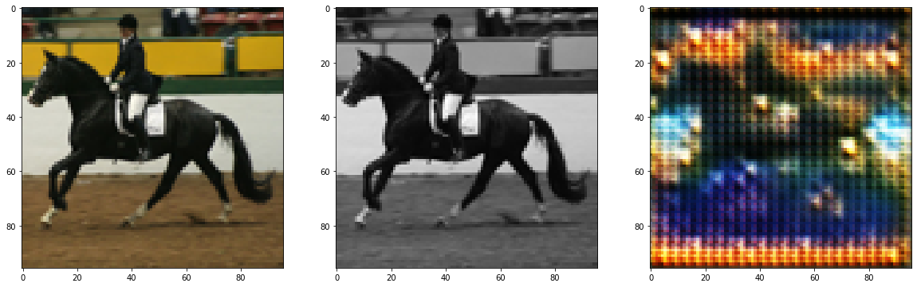

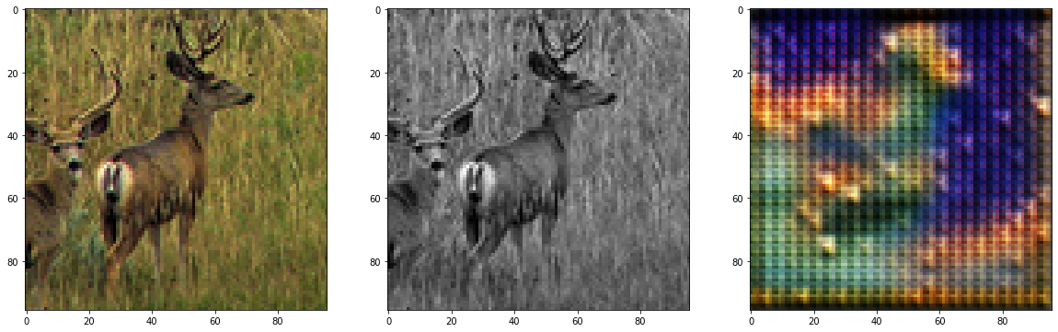

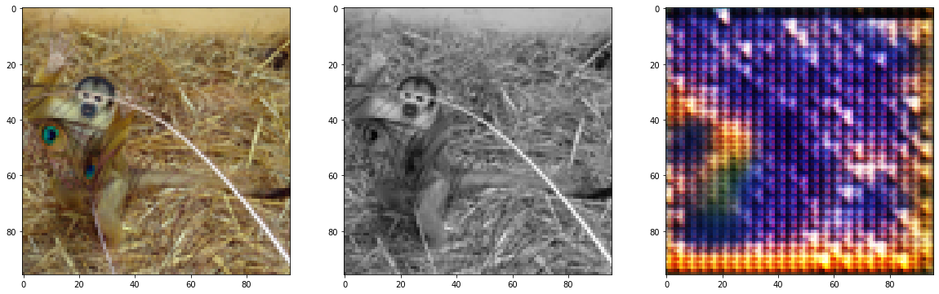

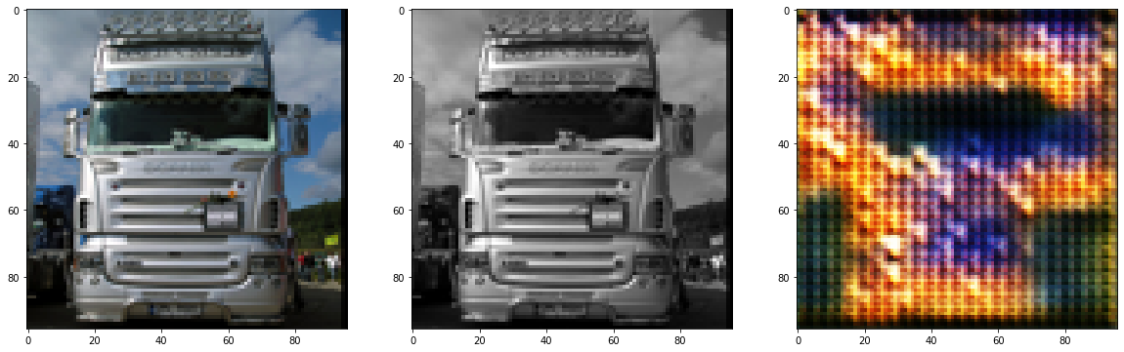

## Results 3

Using a deeper network

Generator: 3 downsamplig convolutions + 9 residual blocks + 3 upsampling convolutions

epochs = 20

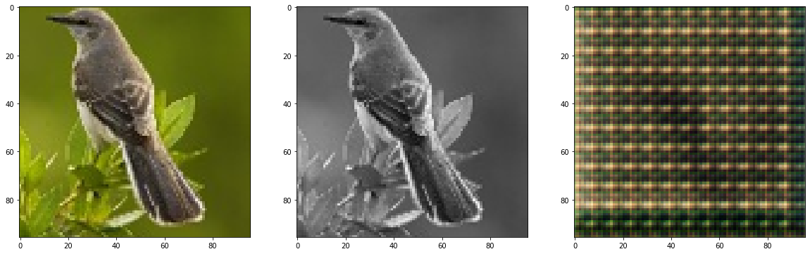

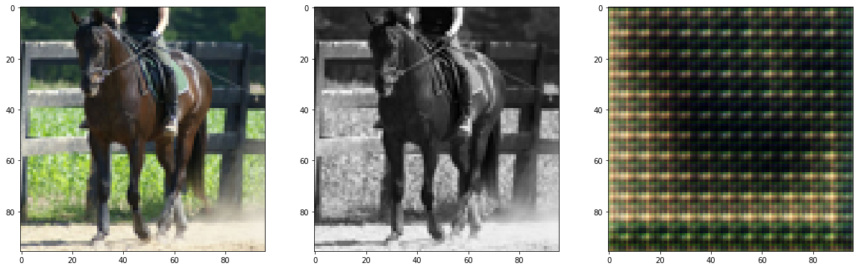

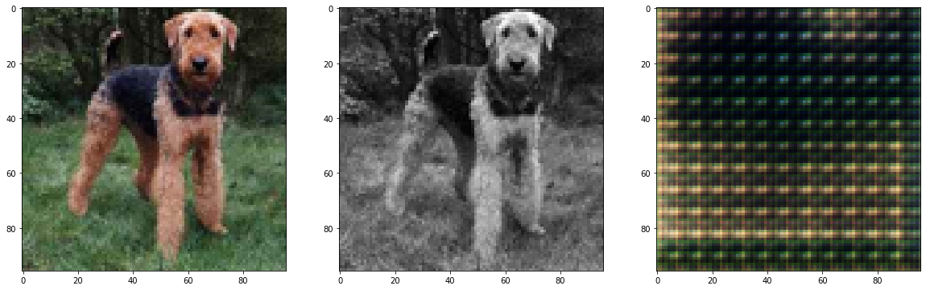

## Results 4

Same network as Results 3

Epochs = 60

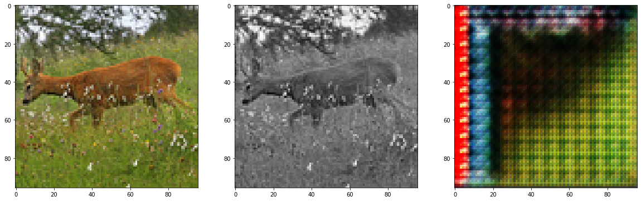

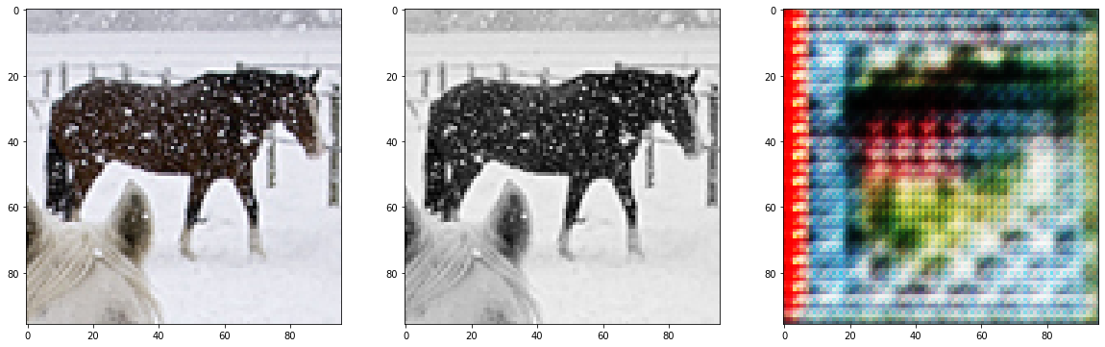

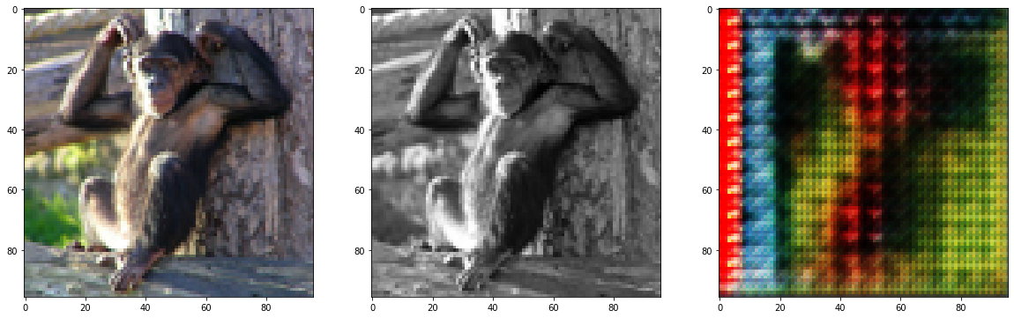

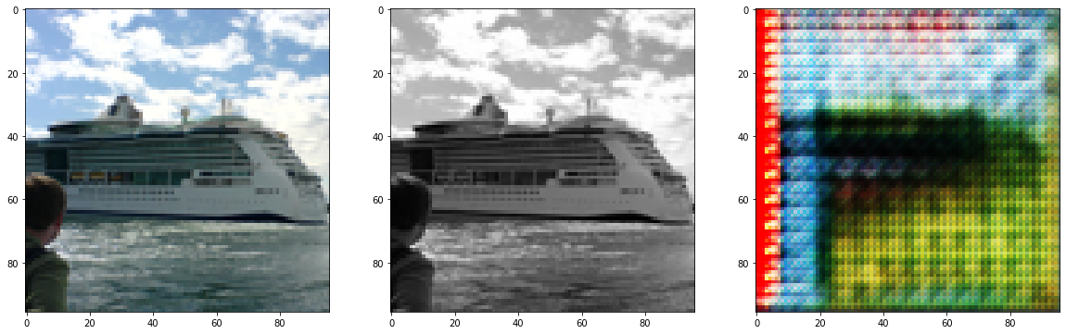

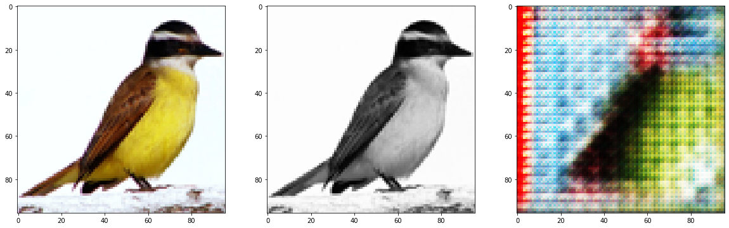

Epoch [1/60], Step [79/79], Gen. Loss: 0.4148, Disc Loss: 0.7367

Epoch [2/60], Step [79/79], Gen. Loss: 0.4550, Disc Loss: 0.7222

Epoch [3/60], Step [79/79], Gen. Loss: 0.4798, Disc Loss: 0.7105

Epoch [4/60], Step [79/79], Gen. Loss: 0.4943, Disc Loss: 0.6984

Epoch [5/60], Step [79/79], Gen. Loss: 0.5017, Disc Loss: 0.7022

Epoch [6/60], Step [79/79], Gen. Loss: 0.5157, Disc Loss: 0.6910

Epoch [7/60], Step [79/79], Gen. Loss: 0.5246, Disc Loss: 0.6923

Epoch [8/60], Step [79/79], Gen. Loss: 0.5254, Disc Loss: 0.6932

Epoch [9/60], Step [79/79], Gen. Loss: 0.5273, Disc Loss: 0.7050

Epoch [10/60], Step [79/79], Gen. Loss: 0.5455, Disc Loss: 0.6919

Epoch [11/60], Step [79/79], Gen. Loss: 0.5650, Disc Loss: 0.6960

Epoch [12/60], Step [79/79], Gen. Loss: 0.5917, Disc Loss: 0.6930

Epoch [13/60], Step [79/79], Gen. Loss: 0.6006, Disc Loss: 0.6944

Epoch [14/60], Step [79/79], Gen. Loss: 0.5973, Disc Loss: 0.6919

Epoch [15/60], Step [79/79], Gen. Loss: 0.5847, Disc Loss: 0.6932

Epoch [16/60], Step [79/79], Gen. Loss: 0.5951, Disc Loss: 0.6965

Epoch [17/60], Step [79/79], Gen. Loss: 0.6030, Disc Loss: 0.6923

Epoch [18/60], Step [79/79], Gen. Loss: 0.6039, Disc Loss: 0.6928

Epoch [19/60], Step [79/79], Gen. Loss: 0.6119, Disc Loss: 0.6937

Epoch [20/60], Step [79/79], Gen. Loss: 0.6288, Disc Loss: 0.6913

Epoch [21/60], Step [79/79], Gen. Loss: 0.6338, Disc Loss: 0.6921

Epoch [22/60], Step [79/79], Gen. Loss: 0.6317, Disc Loss: 0.6951

Epoch [23/60], Step [79/79], Gen. Loss: 0.6519, Disc Loss: 0.6930

Epoch [24/60], Step [79/79], Gen. Loss: 0.6556, Disc Loss: 0.6918

Epoch [25/60], Step [79/79], Gen. Loss: 0.6486, Disc Loss: 0.6914

Epoch [26/60], Step [79/79], Gen. Loss: 0.6500, Disc Loss: 0.6927

Epoch [27/60], Step [79/79], Gen. Loss: 0.6474, Disc Loss: 0.6929

Epoch [28/60], Step [79/79], Gen. Loss: 0.6560, Disc Loss: 0.6928

Epoch [29/60], Step [79/79], Gen. Loss: 0.6608, Disc Loss: 0.6939

Epoch [30/60], Step [79/79], Gen. Loss: 0.6609, Disc Loss: 0.6933

Epoch [31/60], Step [79/79], Gen. Loss: 0.6659, Disc Loss: 0.6929

Epoch [32/60], Step [79/79], Gen. Loss: 0.6614, Disc Loss: 0.6914

Epoch [33/60], Step [79/79], Gen. Loss: 0.6550, Disc Loss: 0.6924

Epoch [34/60], Step [79/79], Gen. Loss: 0.6553, Disc Loss: 0.6908

Epoch [35/60], Step [79/79], Gen. Loss: 0.6519, Disc Loss: 0.6892

Epoch [36/60], Step [79/79], Gen. Loss: 0.6485, Disc Loss: 0.6859

Epoch [37/60], Step [79/79], Gen. Loss: 0.6451, Disc Loss: 0.6876

Epoch [38/60], Step [79/79], Gen. Loss: 0.6436, Disc Loss: 0.6877

Epoch [39/60], Step [79/79], Gen. Loss: 0.6445, Disc Loss: 0.6841

Epoch [40/60], Step [79/79], Gen. Loss: 0.6431, Disc Loss: 0.6759

Epoch [41/60], Step [79/79], Gen. Loss: 0.6515, Disc Loss: 0.6597

Epoch [42/60], Step [79/79], Gen. Loss: 0.6648, Disc Loss: 0.6415

Epoch [43/60], Step [79/79], Gen. Loss: 0.6687, Disc Loss: 0.6278

Epoch [44/60], Step [79/79], Gen. Loss: 0.6537, Disc Loss: 0.6407

Epoch [45/60], Step [79/79], Gen. Loss: 0.6666, Disc Loss: 0.6202

Epoch [46/60], Step [79/79], Gen. Loss: 0.6534, Disc Loss: 0.6297

Epoch [47/60], Step [79/79], Gen. Loss: 0.6528, Disc Loss: 0.6341

Epoch [48/60], Step [79/79], Gen. Loss: 0.6653, Disc Loss: 0.6118

Epoch [49/60], Step [79/79], Gen. Loss: 0.6516, Disc Loss: 0.6293

Epoch [50/60], Step [79/79], Gen. Loss: 0.6750, Disc Loss: 0.6218

Epoch [51/60], Step [79/79], Gen. Loss: 0.6573, Disc Loss: 0.6244

Epoch [52/60], Step [79/79], Gen. Loss: 0.6719, Disc Loss: 0.6175

Epoch [53/60], Step [79/79], Gen. Loss: 0.6644, Disc Loss: 0.6066

Epoch [54/60], Step [79/79], Gen. Loss: 0.6702, Disc Loss: 0.6068

Epoch [55/60], Step [79/79], Gen. Loss: 0.6696, Disc Loss: 0.6010

Epoch [56/60], Step [79/79], Gen. Loss: 0.6689, Disc Loss: 0.5984

Epoch [57/60], Step [79/79], Gen. Loss: 0.6704, Disc Loss: 0.6008

Epoch [58/60], Step [79/79], Gen. Loss: 0.6723, Disc Loss: 0.5981

Epoch [59/60], Step [79/79], Gen. Loss: 0.6821, Disc Loss: 0.5944

Epoch [60/60], Step [79/79], Gen. Loss: 0.6748, Disc Loss: 0.5956

## Results 5

Generator: 2 downsamplig convolutions + 6 residual blocks + 2 upsampling convolutions

Also, apply data augmentation

ALSO, and IMPORTANT: Added L1 norm to Generator loss:

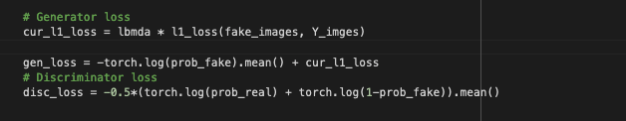

Epochs = 20

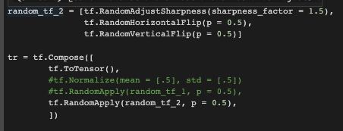

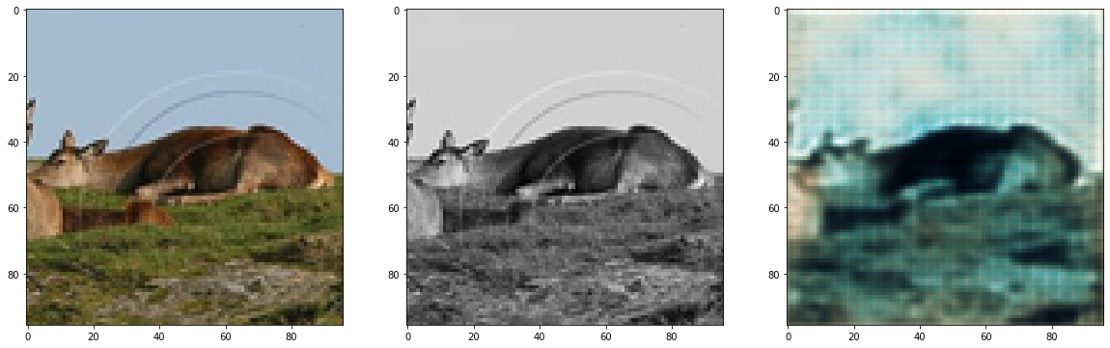

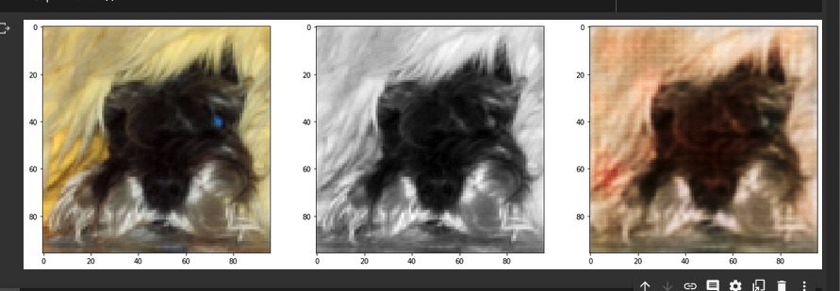

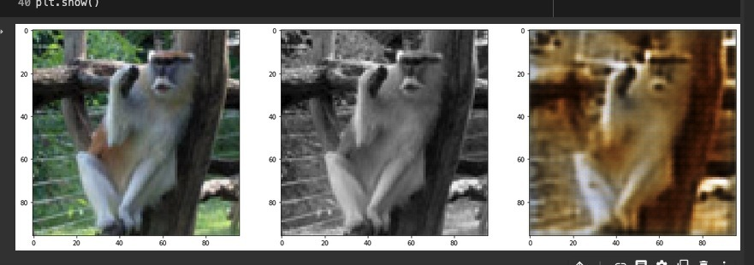

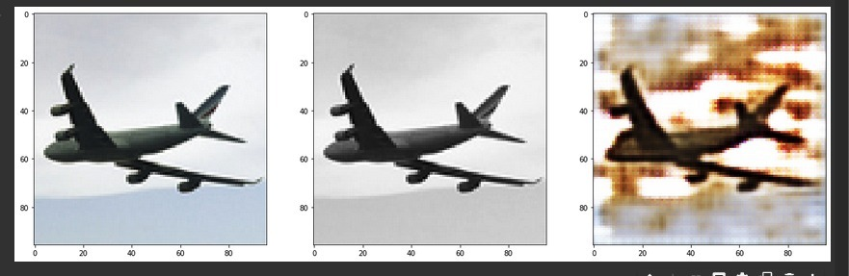

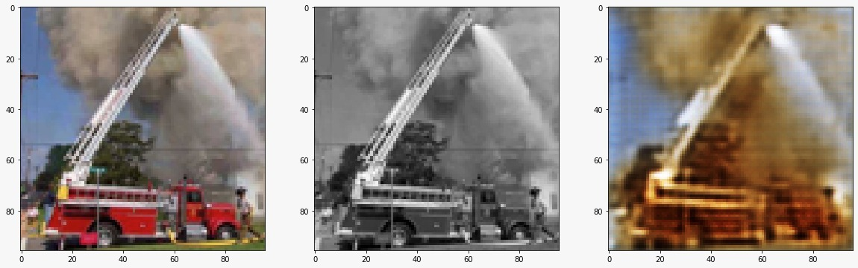

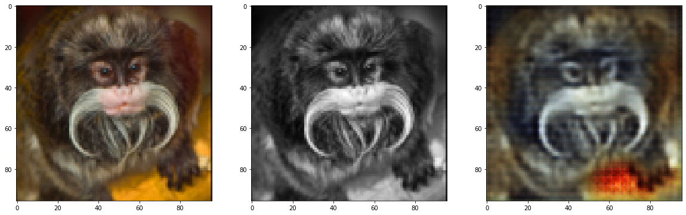

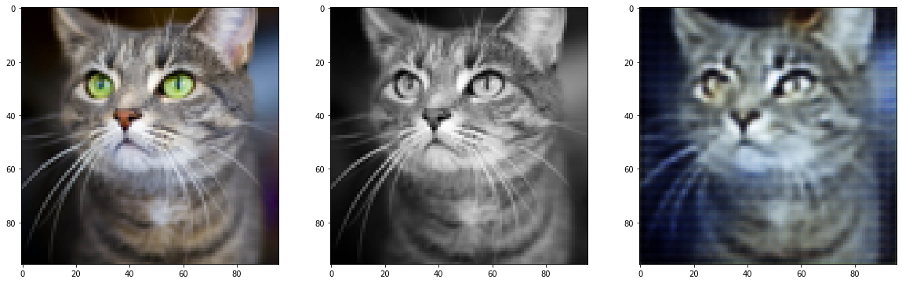

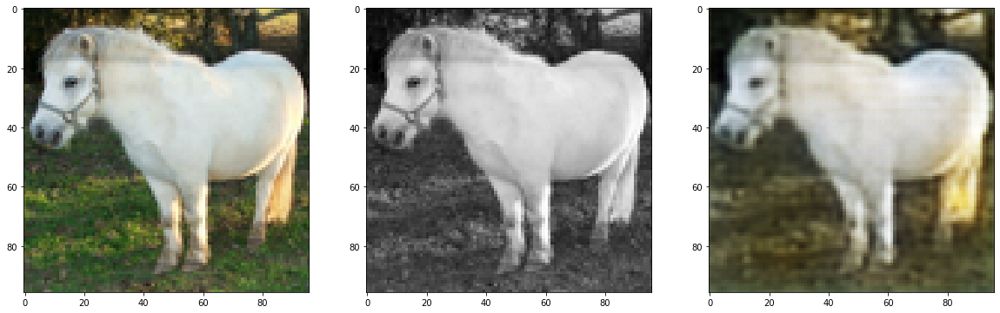

## Results 6

Generator: 2 downsamplig convolutions + 9 residual blocks + 2 upsampling convolutions

Also, apply data augmentation

epochs = 60

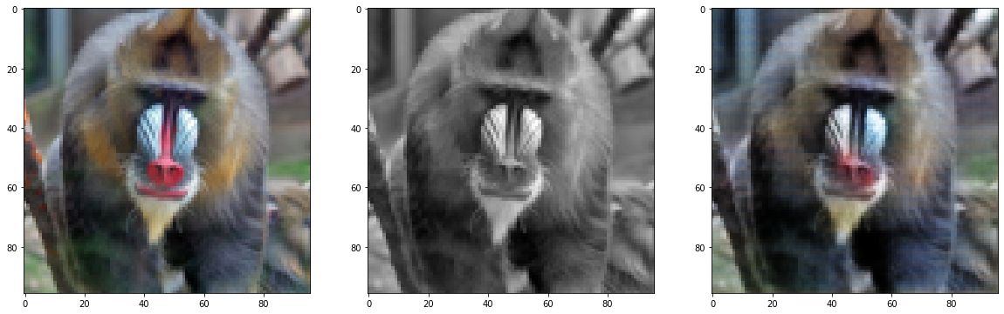

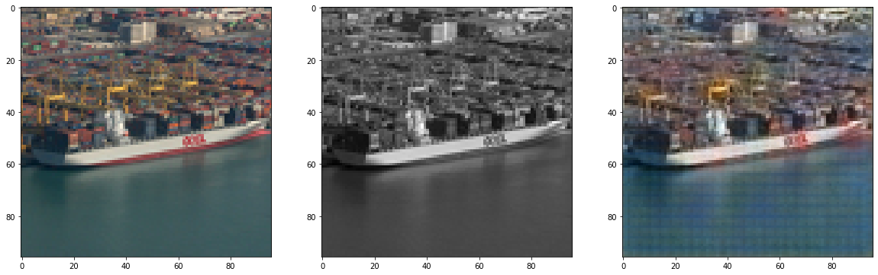

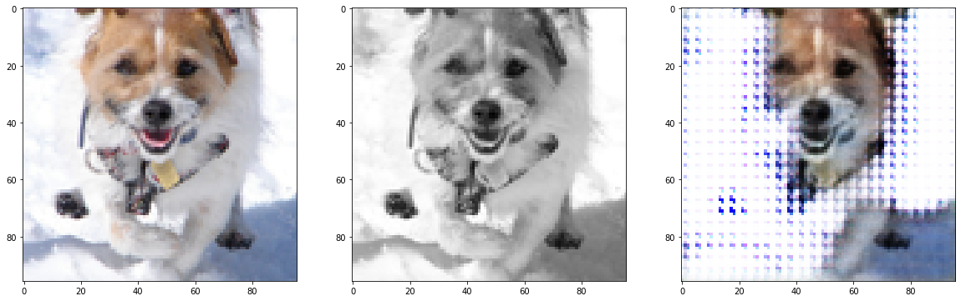

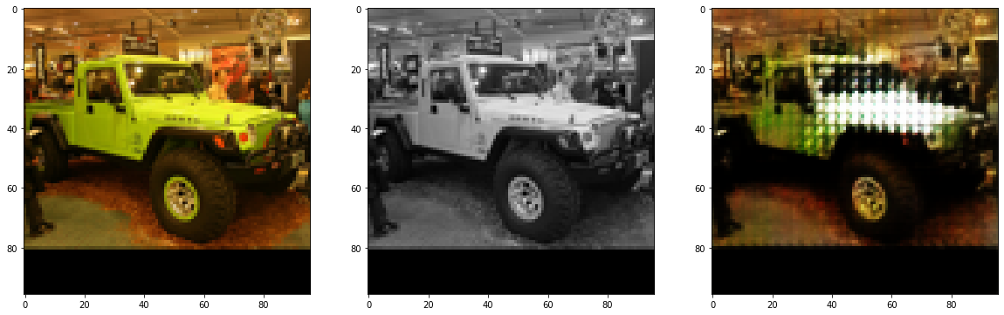

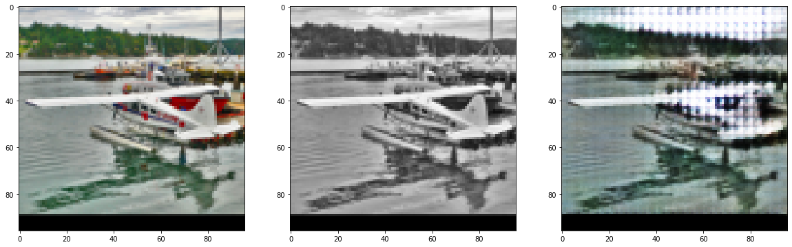

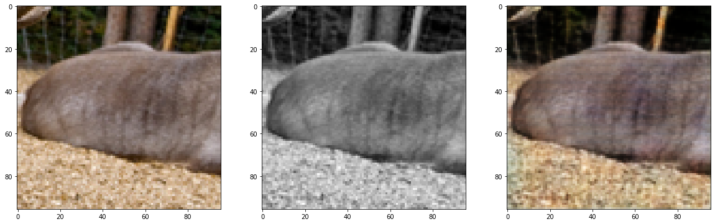

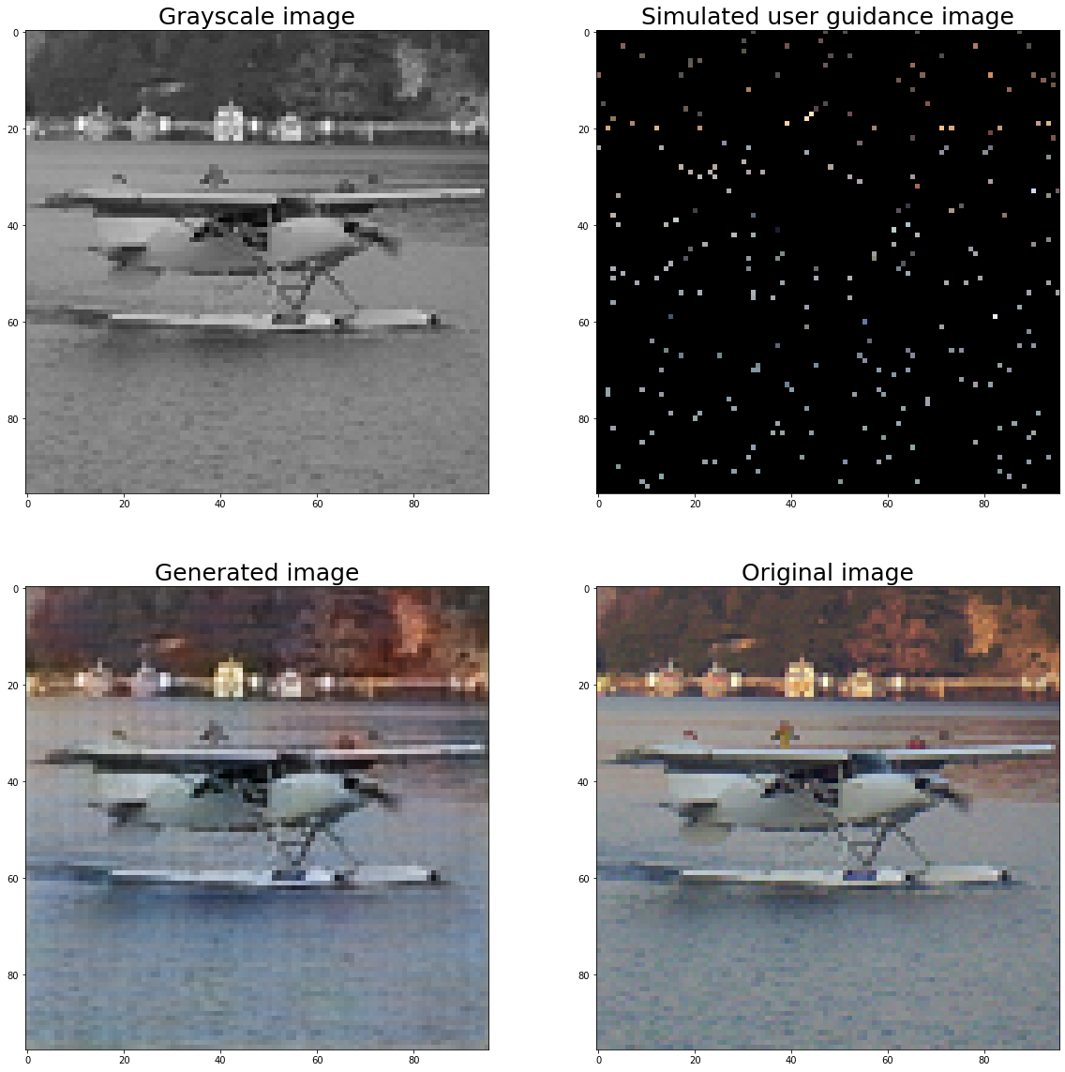

250 pixeles as user guidance

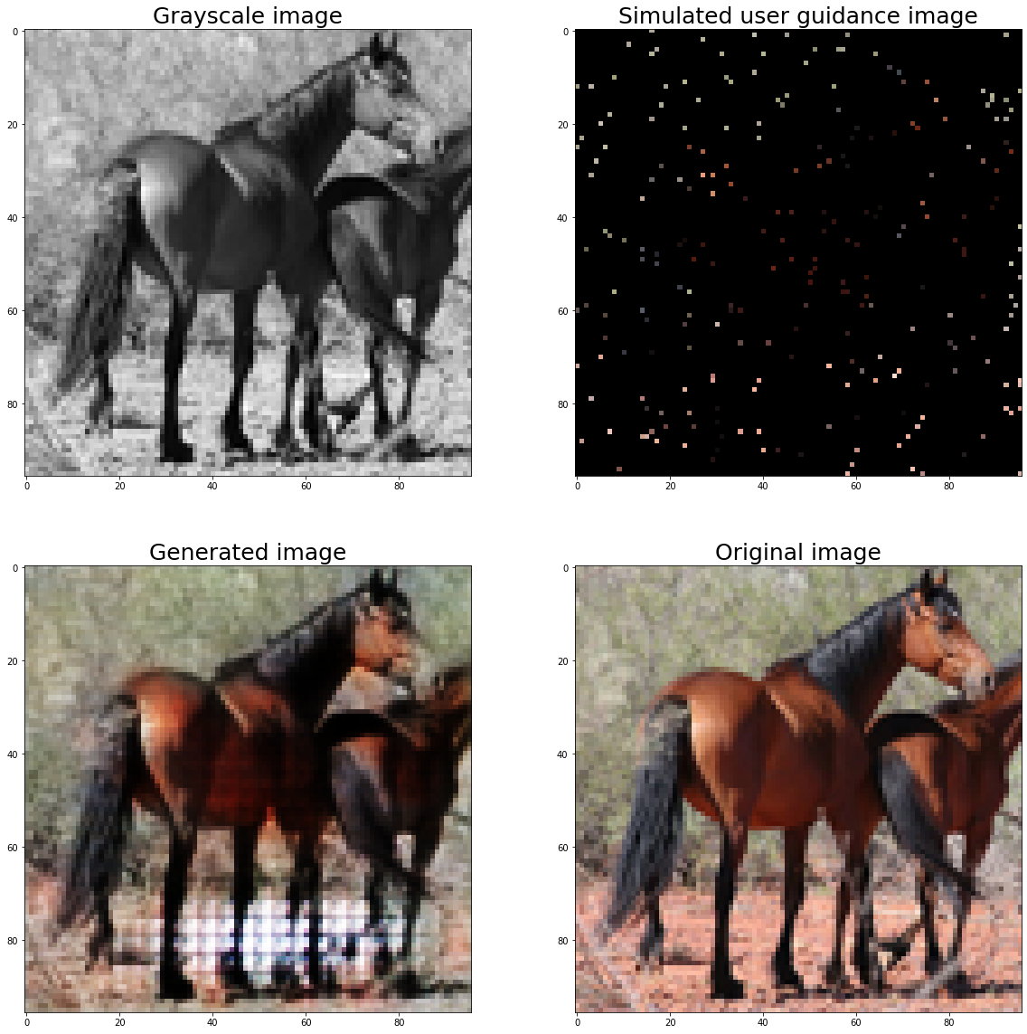

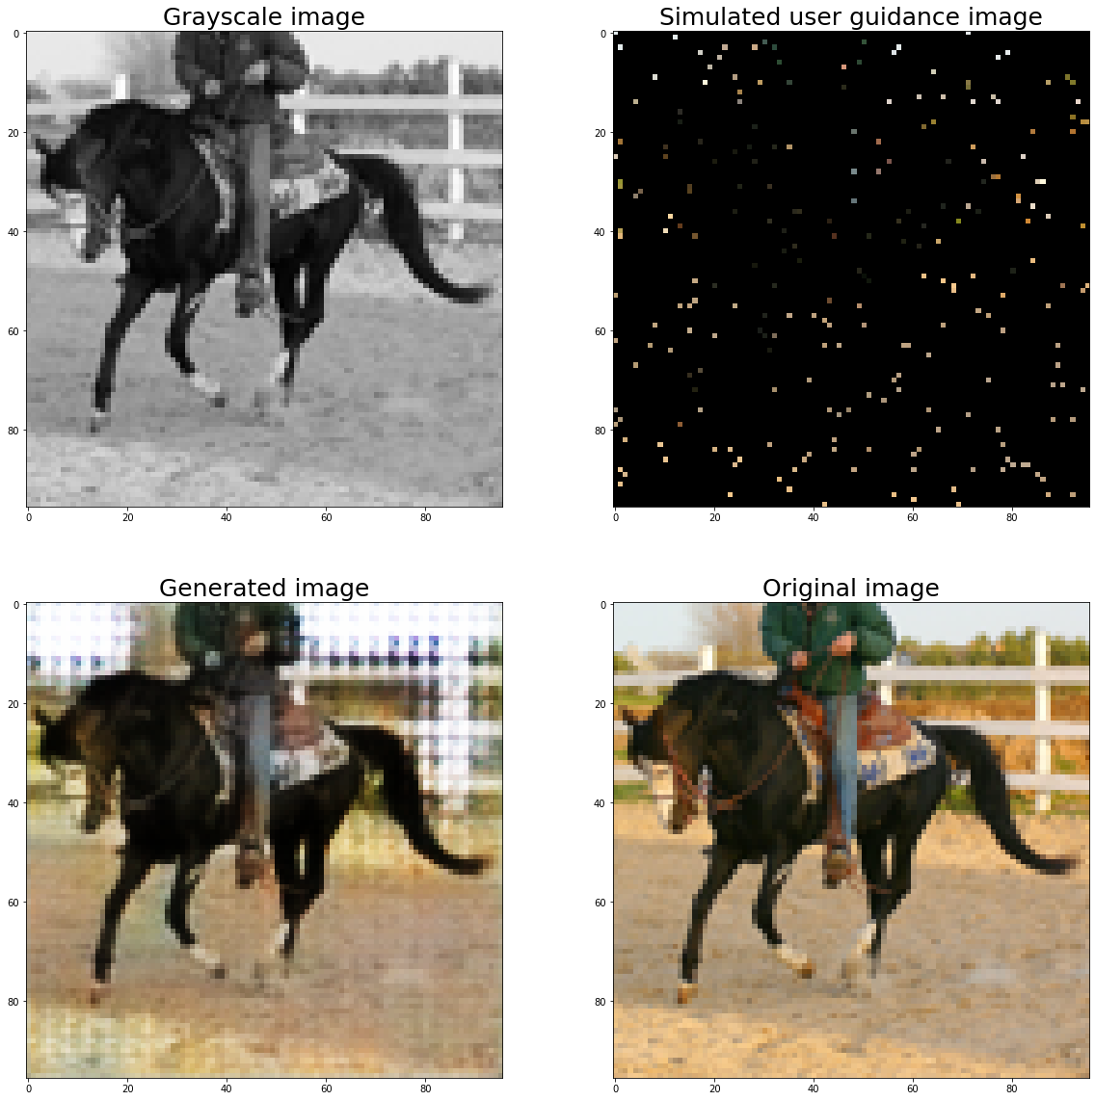

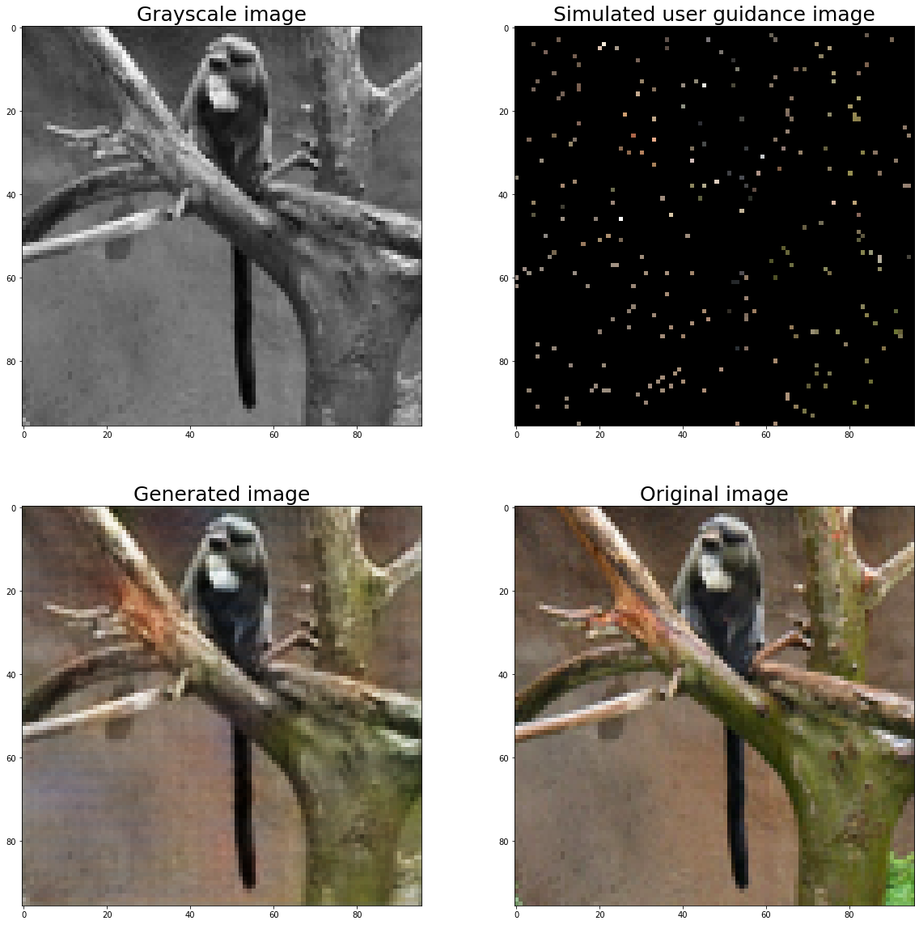

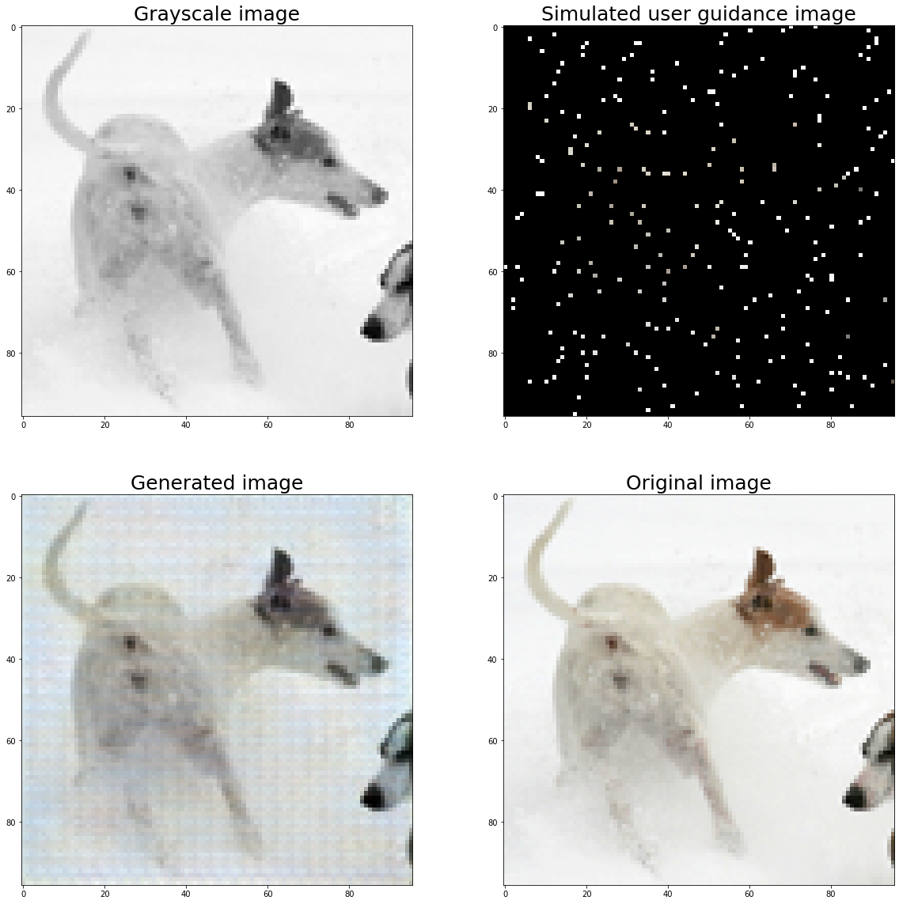

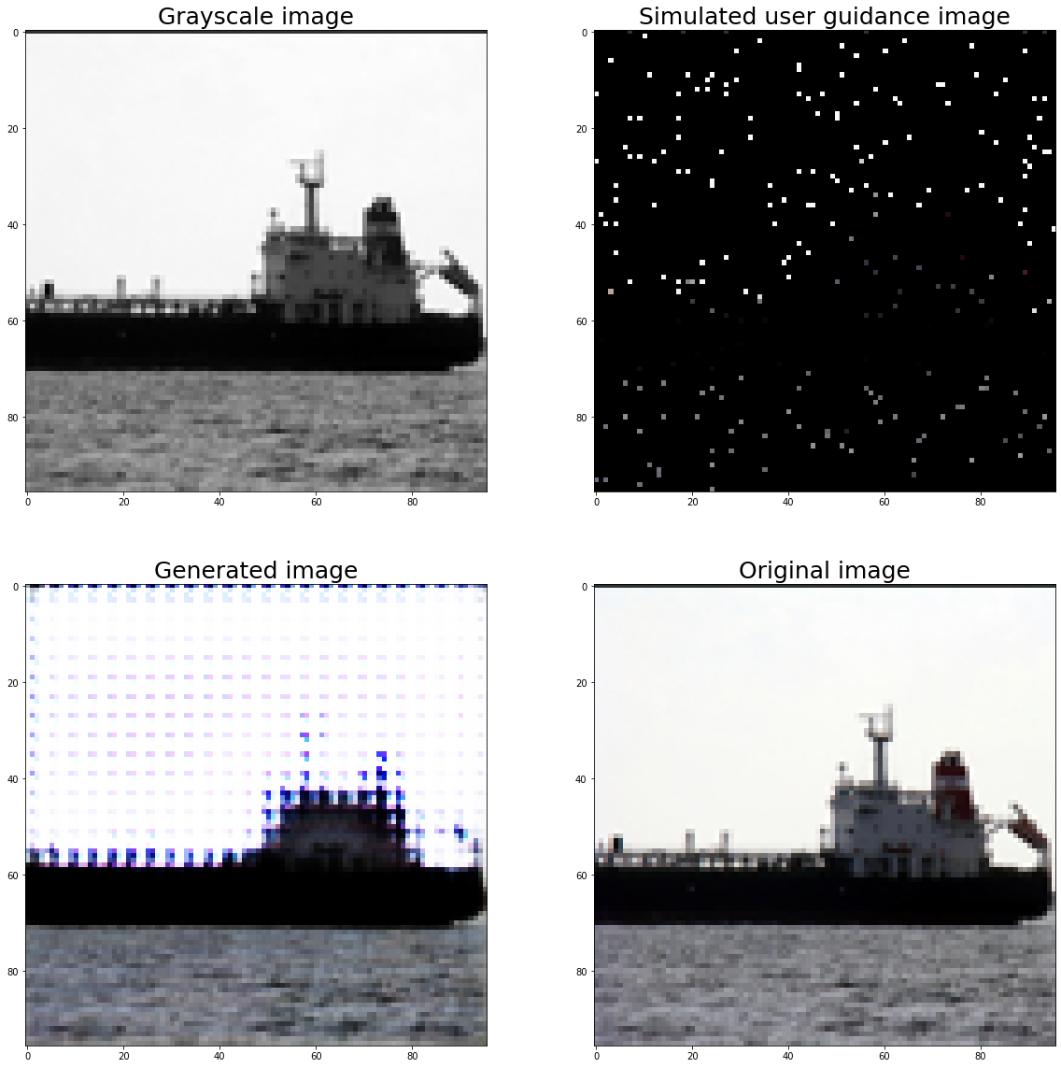

32 points as user guidance

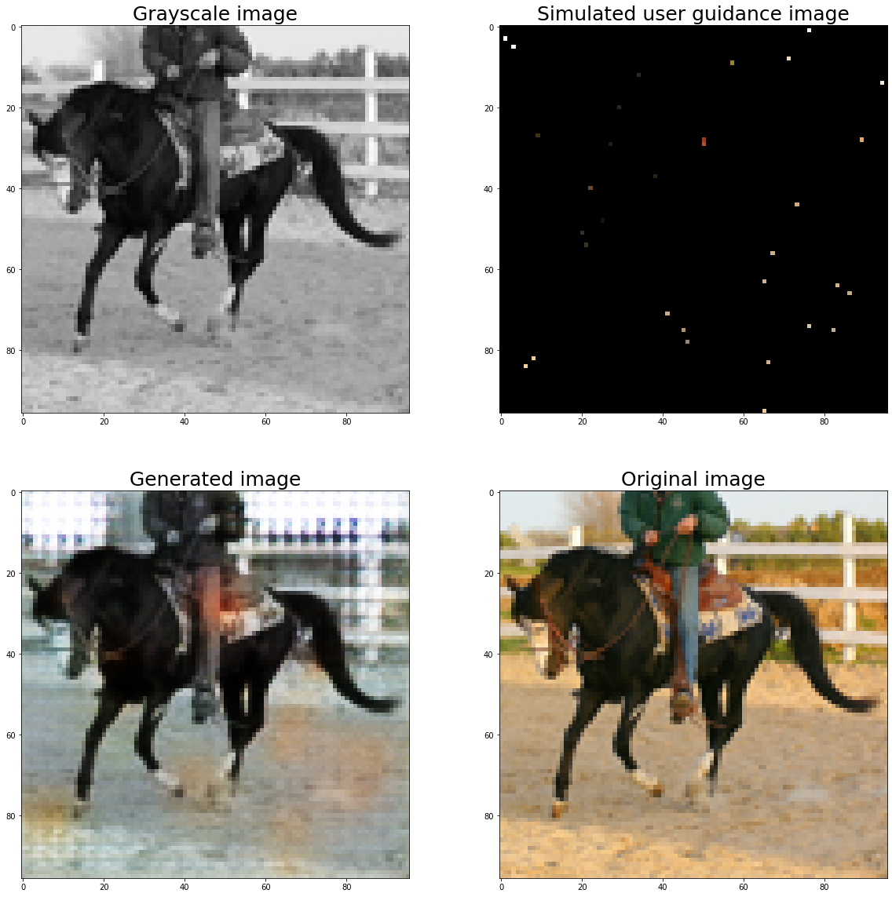

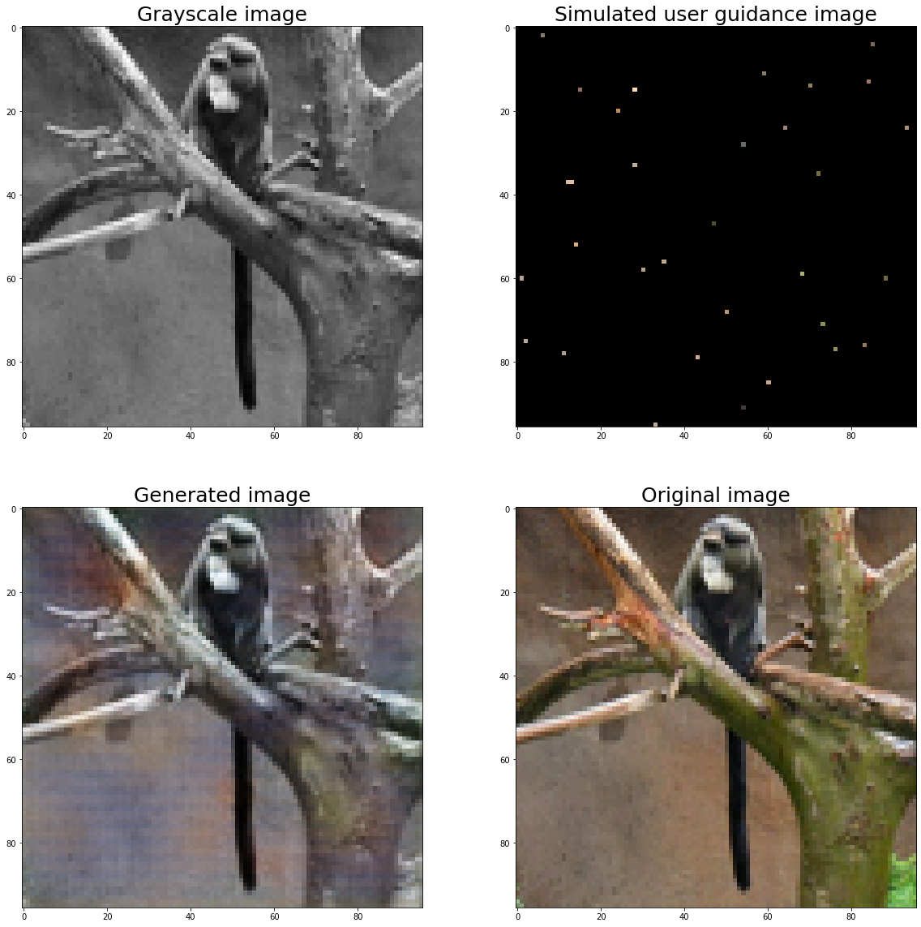

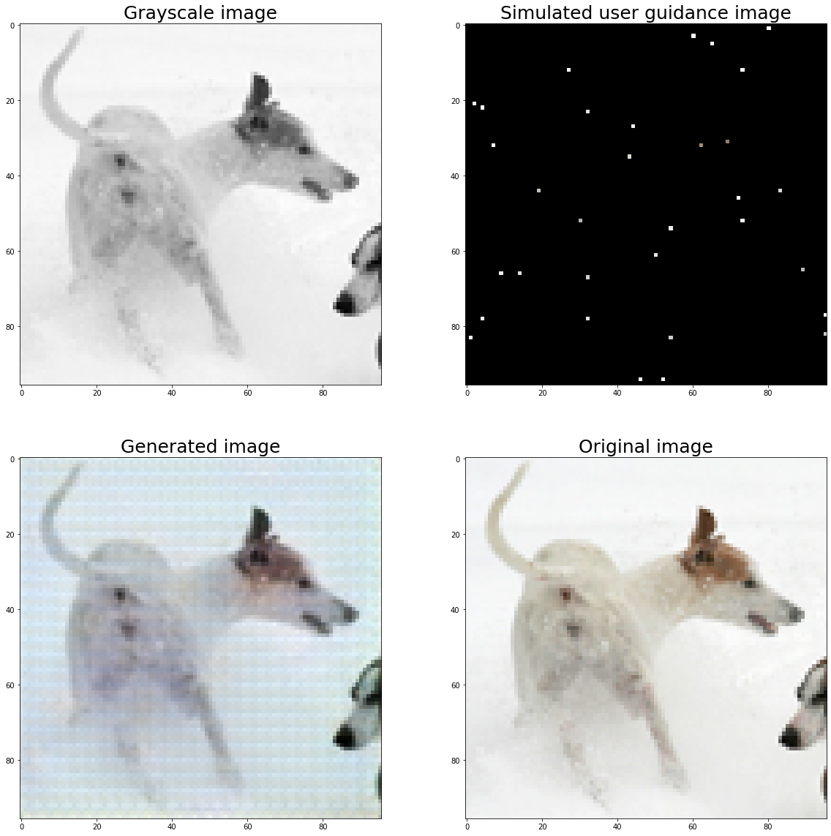

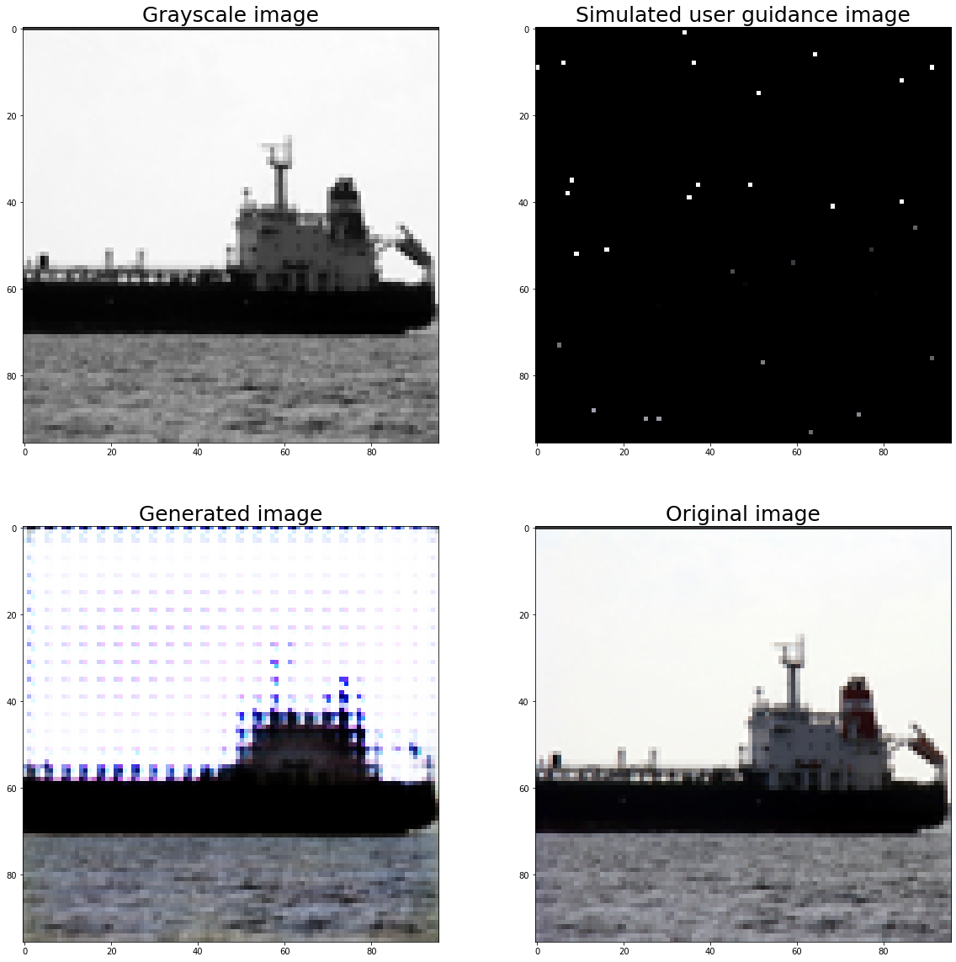

0 points

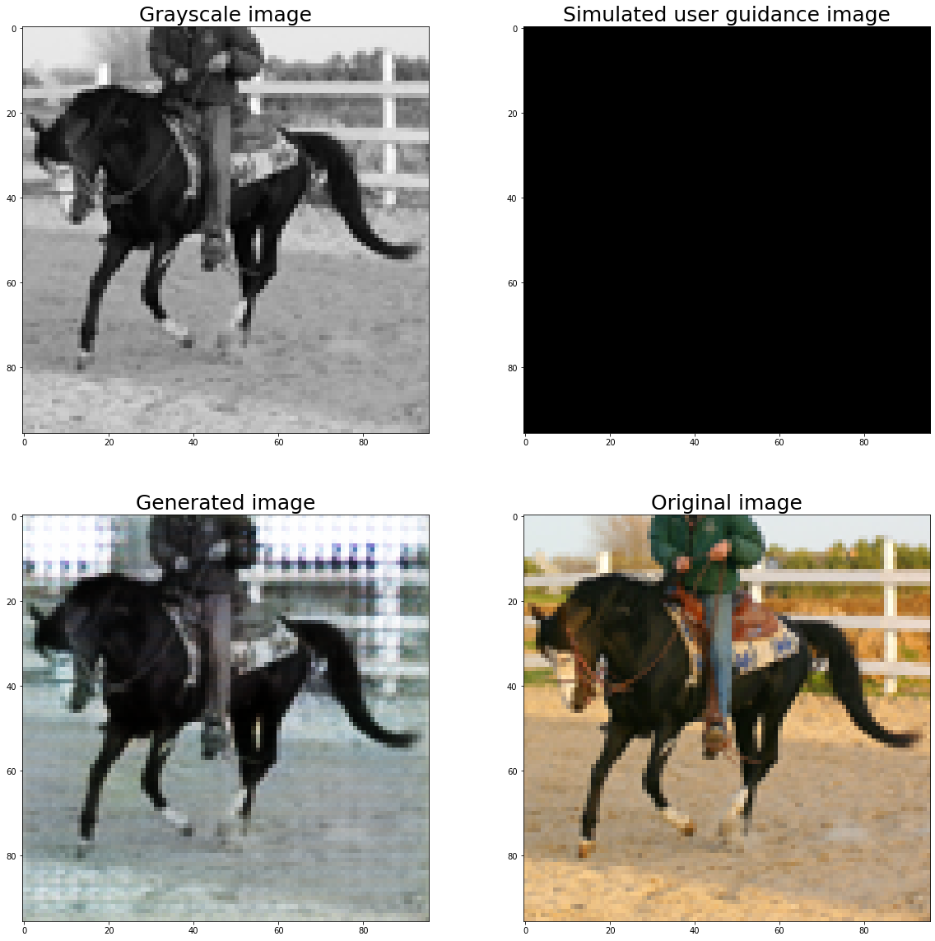

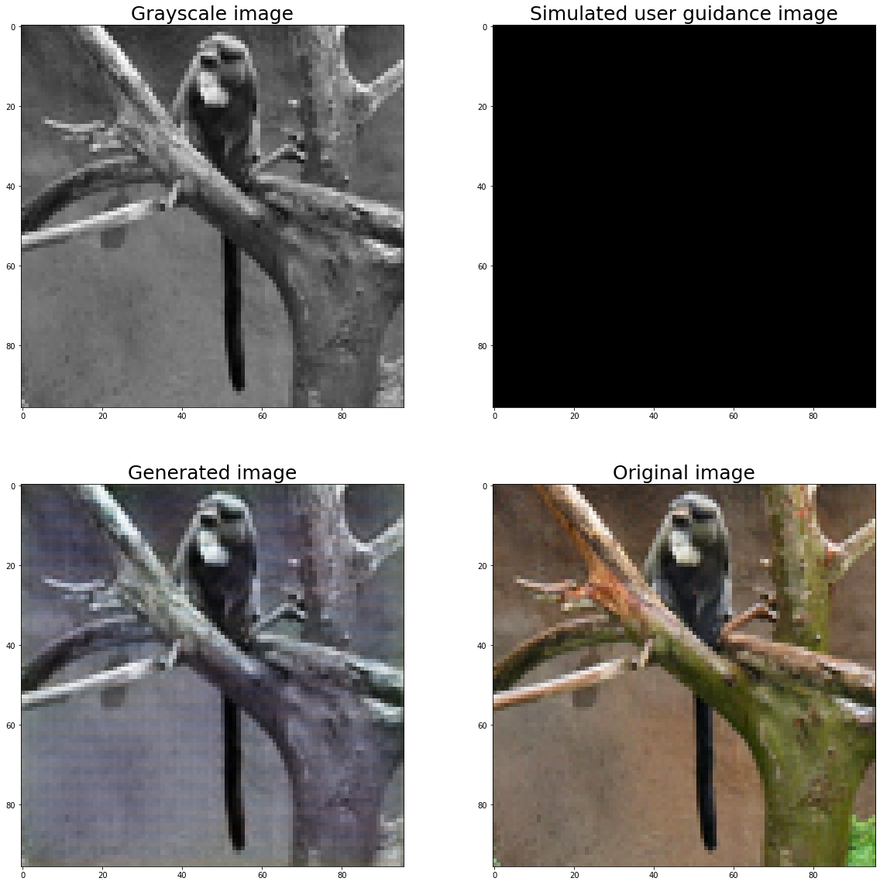

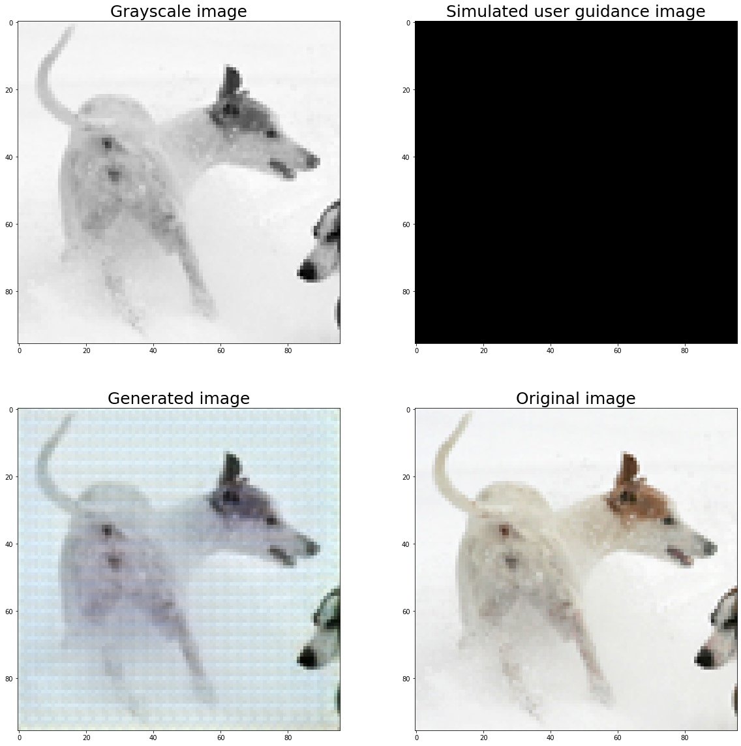

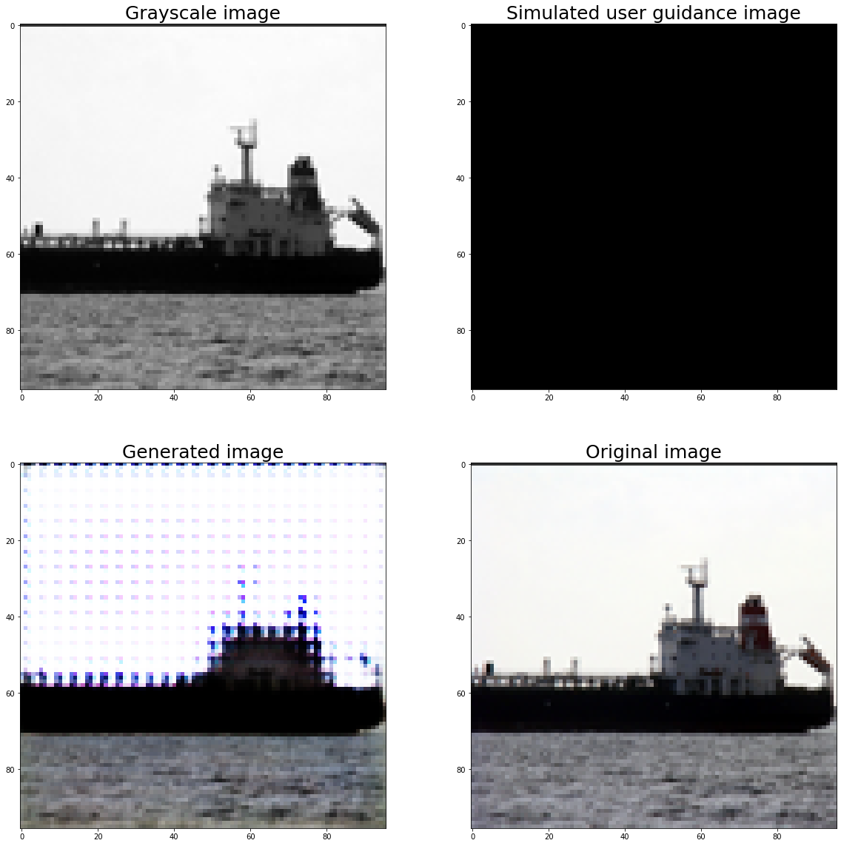

**Result 8 : 60 points for the mask, 100 iterations**

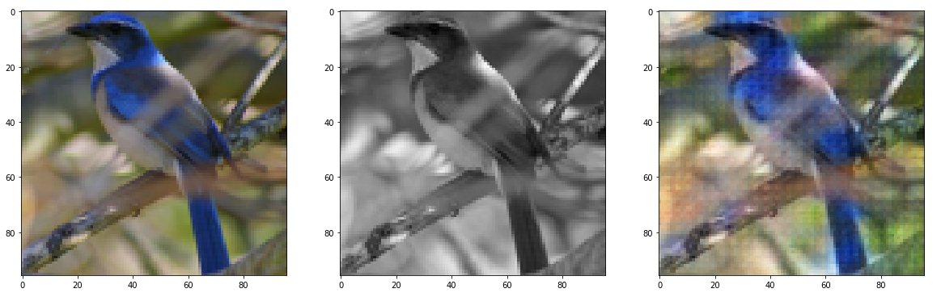

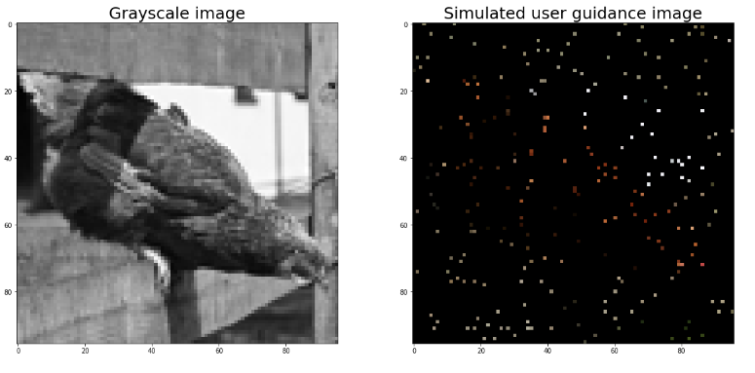

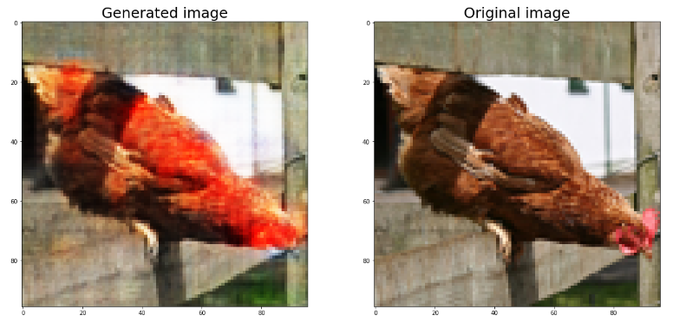

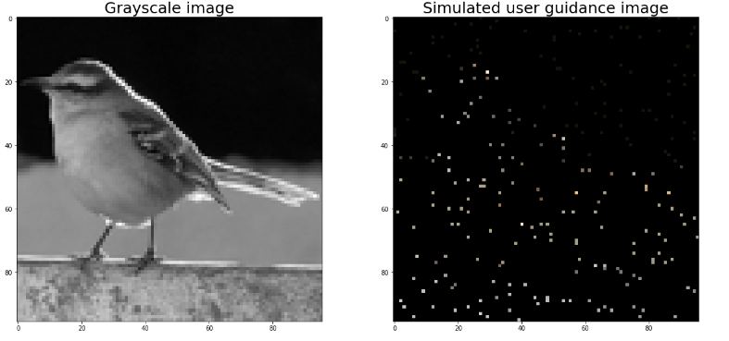

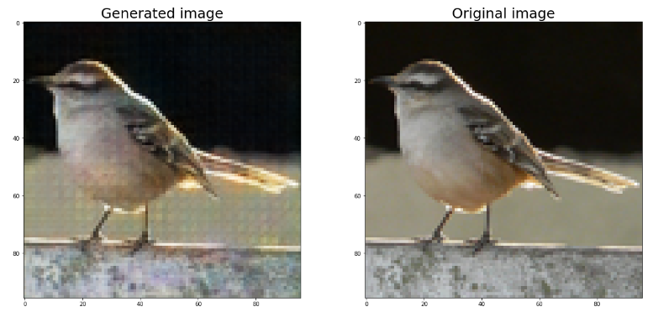

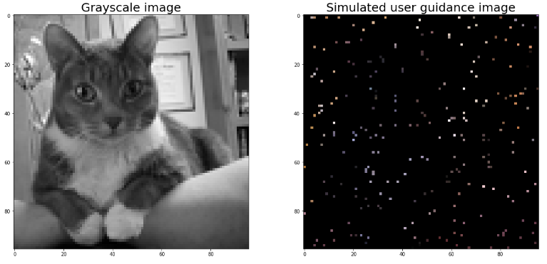

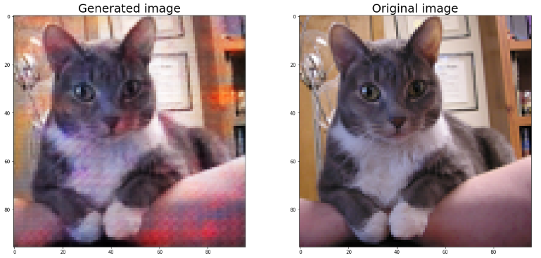

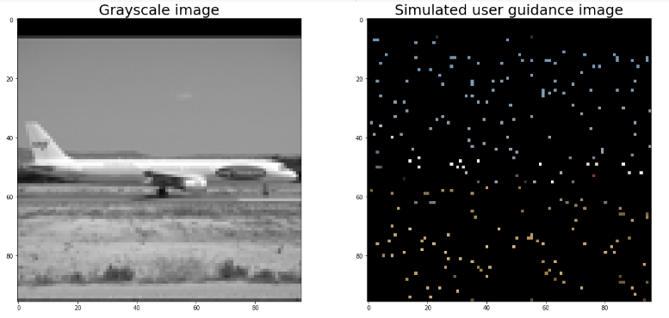

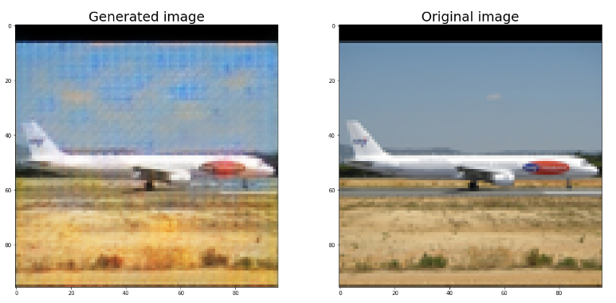

—>

experimento:

mirar sobre todo el loss si baja… y cual tiene que ganar…

probar de 20 , y luego 60, 100…